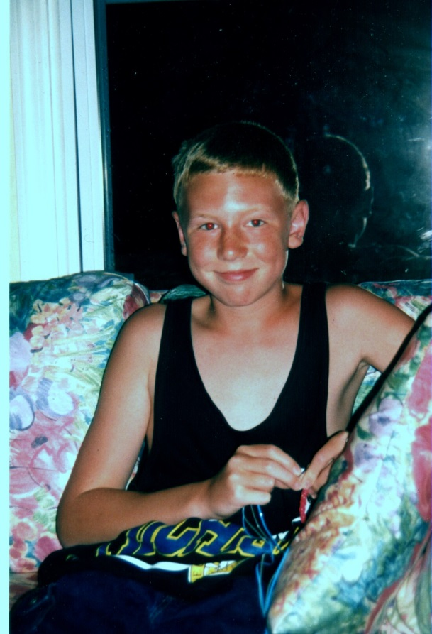

Richard James Schwartz - 1999

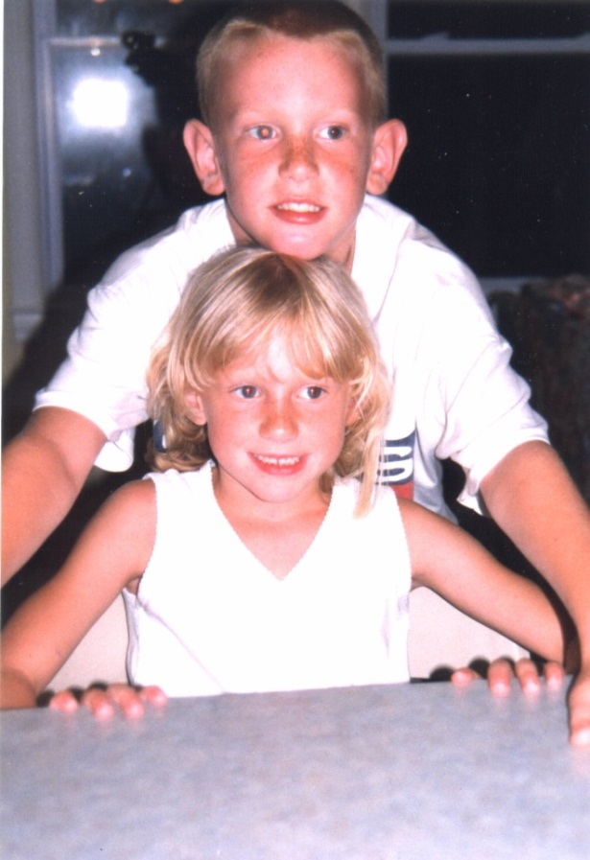

Robert John & Jacquelyn Michelle Schwartz – 1999